Sphere Center

Definition
# Source: AI Source: Provided by: [Data Path: Persons Table -> ID Column: 1, Name_En Column: Motasem Essam] -> From: [ChatGPT] on [7/25/2026]
The center of a sphere is the point inside the sphere that is equidistant from every point on its surface. It is the reference point from which the sphere’s radius is measured and the point through which every diameter passes.
A sphere consists of all points in three-dimensional space at a fixed distance $R$ from its center $O$, where $R$ is the radius.
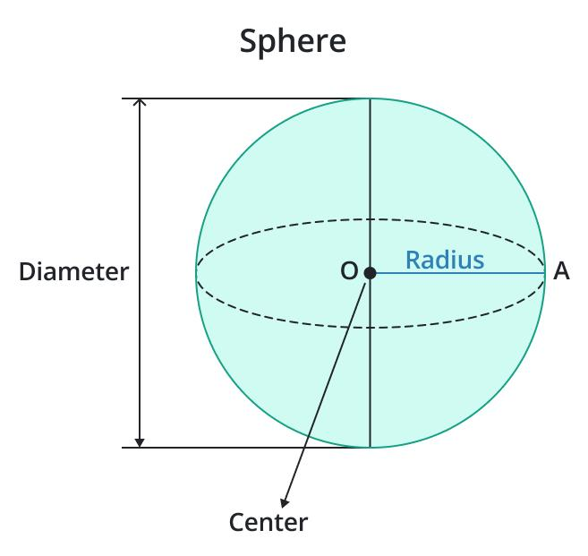
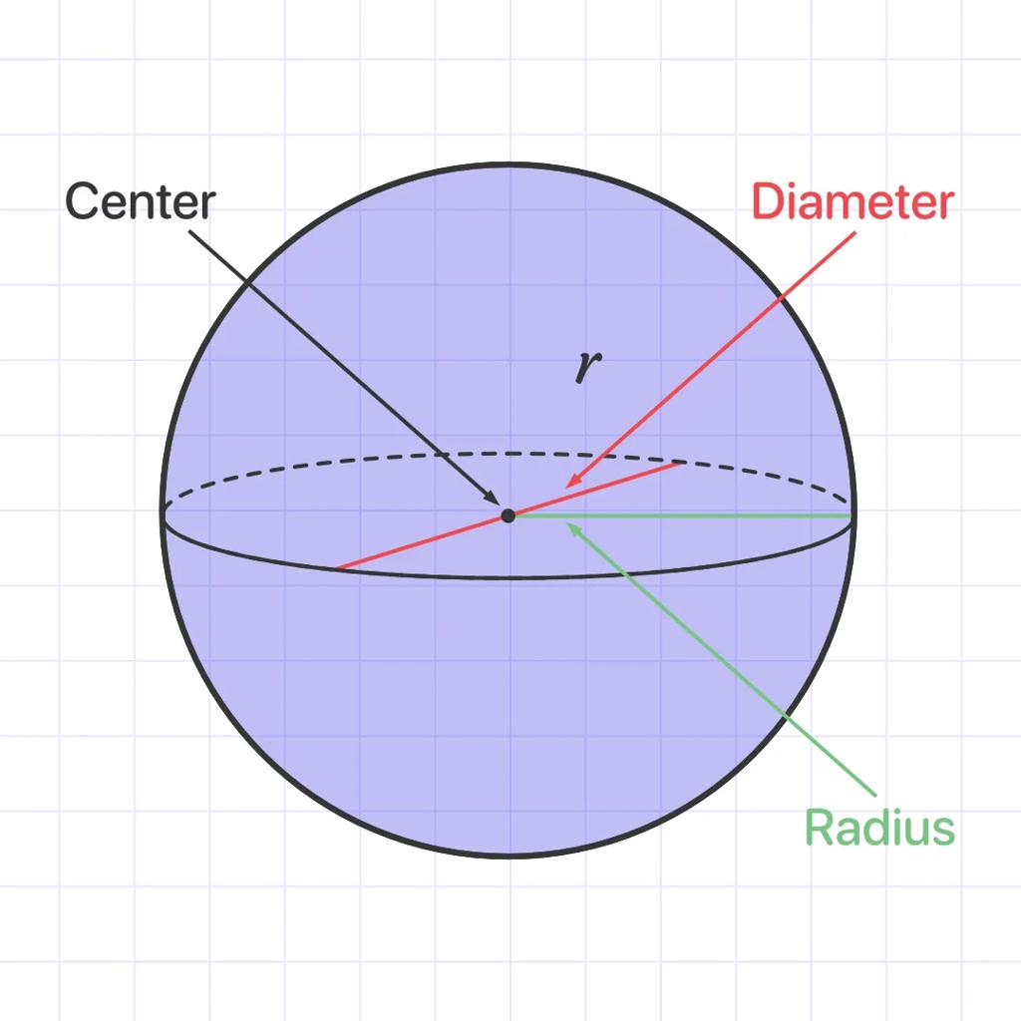
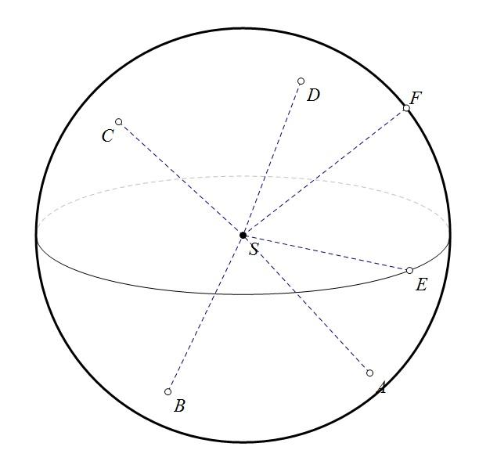

Simple Definition
# Source: AI Source: Provided by: [Data Path: Persons Table -> ID Column: 1, Name_En Column: Motasem Essam] -> From: [ChatGPT] on [7/25/2026]
The sphere center is the point exactly halfway along every diameter of the sphere.
- Every point on the sphere’s surface is the same distance from the center.
- The distance from the center to the surface is the radius.
- Every diameter passes through the center.
- A perfect sphere has exactly one geometric center.

Geometric Representation
# Source: AI Source: Provided by: [Data Path: Persons Table -> ID Column: 1, Name_En Column: Motasem Essam] -> From: [ChatGPT] on [7/25/2026]
Consider a sphere with center $O$ and radius $R$.
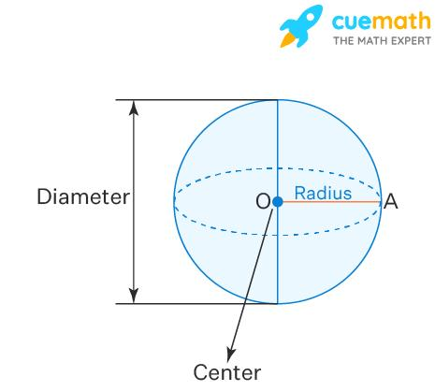
Let $A$ and $B$ be opposite points on the sphere’s surface, with the line segment $AB$ passing through $O$.
The following relationships hold:
$$OA=OB=R$$
$$AB=2R$$
$$AO=OB$$
Therefore, the center is the midpoint of every diameter.

Key Characteristics
# Source: AI Source: Provided by: [Data Path: Persons Table -> ID Column: 1, Name_En Column: Motasem Essam] -> From: [ChatGPT] on [7/25/2026]
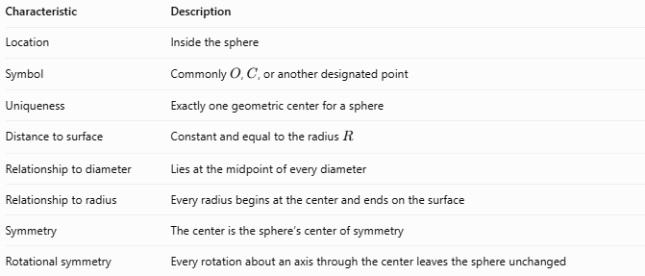
Characteristic | Description
Location | Inside the sphere
Symbol | Commonly $O$, $C$, or another designated point
Uniqueness | Exactly one geometric center for a sphere
Distance to surface | Constant and equal to the radius $R$
Relationship to diameter | Lies at the midpoint of every diameter
Relationship to radius | Every radius begins at the center and ends on the surface
Symmetry | The center is the sphere’s center of symmetry
Rotational symmetry | Every rotation about an axis through the center leaves the sphere unchanged

Mathematical Representation

Sphere equation in three-dimensional coordinates
# Source: AI Source: Provided by: [Data Path: Persons Table -> ID Column: 1, Name_En Column: Motasem Essam] -> From: [ChatGPT] on [7/25/2026]
For a sphere centered at $C=\left(a,b,c\right)$ with radius $R$, the equation is:
$${\left(x-a\right)}^{2}+{\left(y-b\right)}^{2}+{\left(z-c\right)}^{2}=R^{2}$$
The center is:
$$\boxed{C=\left(a,b,c\right)}$$
If the center is at the origin $O=\left(0,0,0\right)$, the equation simplifies to:
$$\boxed{x^{2}+y^{2}+z^{2}=R^{2}}$$

Distance from the center to a surface point
# Source: AI Source: Provided by: [Data Path: Persons Table -> ID Column: 1, Name_En Column: Motasem Essam] -> From: [ChatGPT] on [7/25/2026]
For a surface point $P=\left(x,y,z\right)$ and center $C=\left(a,b,c\right)$:
$$CP=\sqrt{{\left(x-a\right)}^{2}+{\left(y-b\right)}^{2}+{\left(z-c\right)}^{2}}$$
Since $P$ lies on the sphere’s surface:
$$CP=R$$

Finding the center from a diameter
# Source: AI Source: Provided by: [Data Path: Persons Table -> ID Column: 1, Name_En Column: Motasem Essam] -> From: [ChatGPT] on [7/25/2026]
If $A=\left(x_{1},y_{1},z_{1}\right)$ and $B=\left(x_{2},y_{2},z_{2}\right)$ are the endpoints of a diameter, the center is their midpoint:
$$C=\left(\frac{x_{1}+x_{2}}{2},\frac{y_{1}+y_{2}}{2},\frac{z_{1}+z_{2}}{2}\right)$$

Relationship to Other Spherical Elements
# Source: AI Source: Provided by: [Data Path: Persons Table -> ID Column: 1, Name_En Column: Motasem Essam] -> From: [ChatGPT] on [7/25/2026]
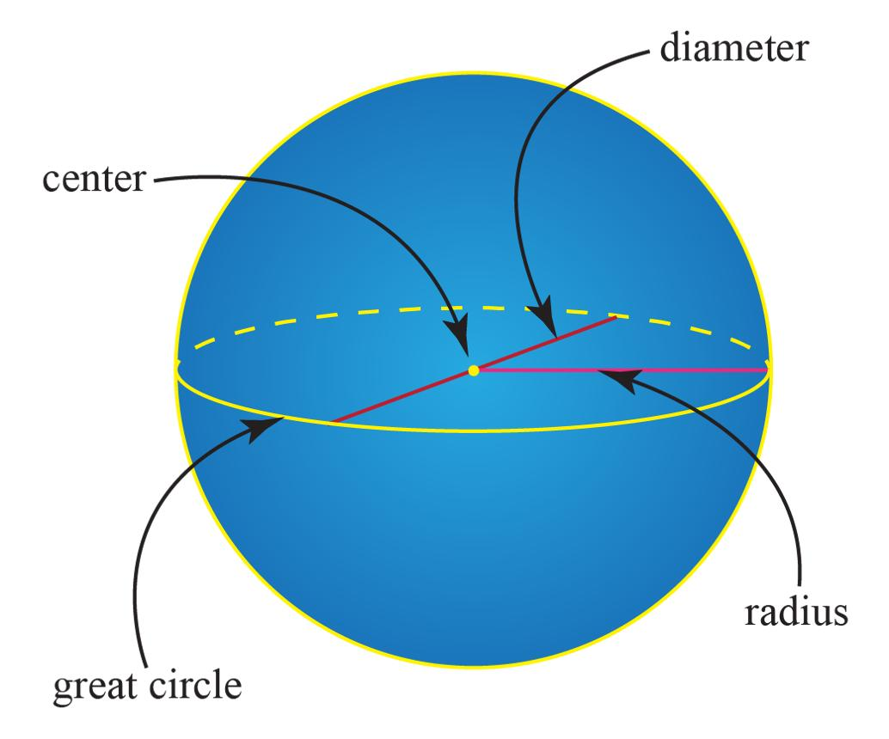
- Radius: A segment connecting the center to a point on the surface.
- Diameter: A segment passing through the center and joining two opposite surface points.
- Sphere poles: Opposite endpoints of a selected diameter.
- Polar axis: A diameter selected as an axis of reference or rotation.
- Great circle: The circular intersection formed when a plane passes through the center.
- Equatorial plane: A plane through the center perpendicular to a selected polar axis.
The center is the common reference point for these elements, but the sphere does not have a unique polar axis unless one is specified.

Worked Examples
# Source: AI Source: Provided by: [Data Path: Persons Table -> ID Column: 1, Name_En Column: Motasem Essam] -> From: [ChatGPT] on [7/25/2026]
Example 1 — Find the radius
A sphere has center $O$. A point $P$ on its surface is $9\text{ cm}$ from $O$.
Since the center-to-surface distance is the radius:
$$R=OP=9\text{ cm}$$
Answer: $9\text{ cm}$.
Example 2 — Find the center from a diameter
The endpoints of a sphere’s diameter are:
$$A=\left(2,4,6\right), B=\left(8,10,12\right)$$
The center is the midpoint:
$$C=\left(\frac{2+8}{2},\frac{4+10}{2},\frac{6+12}{2}\right)$$
$$\boxed{C=\left(5,7,9\right)}$$
Example 3 — Identify the center from the equation
Given the sphere equation:
$${\left(x-3\right)}^{2}+{\left(y+2\right)}^{2}+{\left(z-4\right)}^{2}=25$$
Comparing it with the standard form gives:
$$\boxed{C=\left(3,-2,4\right)}$$
The radius is:
$$R=\sqrt{25}=5$$

Sphere Center vs. Related Concepts
# Source: AI Source: Provided by: [Data Path: Persons Table -> ID Column: 1, Name_En Column: Motasem Essam] -> From: [ChatGPT] on [7/25/2026]
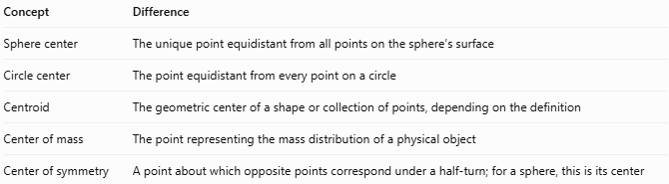
Concept | Difference
Sphere center | The unique point equidistant from all points on the sphere’s surface
Circle center | The point equidistant from every point on a circle
Centroid | The geometric center of a shape or collection of points, depending on the definition
Center of mass | The point representing the mass distribution of a physical object
Center of symmetry | A point about which opposite points correspond under a half-turn; for a sphere, this is its center
For a uniform solid sphere, the center of mass coincides with the geometric center. For a nonuniform object with a spherical exterior, the center of mass may be elsewhere.

Applications
# Source: AI Source: Provided by: [Data Path: Persons Table -> ID Column: 1, Name_En Column: Motasem Essam] -> From: [ChatGPT] on [7/25/2026]
- Coordinate geometry: Defining the equation and position of a sphere.
- Engineering: Measuring radii, diameters, and distances in spherical components.
- Astronomy: Modeling spherical planets and celestial bodies.
- Computer graphics: Positioning, rotating, and rendering spheres.
- Physics: Describing idealized spherical mass distributions and gravitational models.
- Geometry: Constructing radii, diameters, great circles, and spherical cross-sections.

Key Points
# Source: AI Source: Provided by: [Data Path: Persons Table -> ID Column: 1, Name_En Column: Motasem Essam] -> From: [ChatGPT] on [7/25/2026]
- A sphere has exactly one geometric center.
- Every point on the sphere’s surface is the same distance from the center.
- That distance is the radius $R$.
- Every diameter passes through the center.
- The center is the midpoint of every diameter.
- A sphere’s center can be found using a diameter’s endpoints or its standard coordinate equation.
- The geometric center and physical center of mass coincide only under suitable mass-distribution conditions.

Conclusion
# Source: AI Source: Provided by: [Data Path: Persons Table -> ID Column: 1, Name_En Column: Motasem Essam] -> From: [ChatGPT] on [7/25/2026]
The sphere center is the fundamental reference point of a sphere. It defines the radius, lies at the midpoint of every diameter, and determines the sphere’s standard coordinate equation. It also provides the reference for locating poles, axes, great circles, and other spherical elements.

